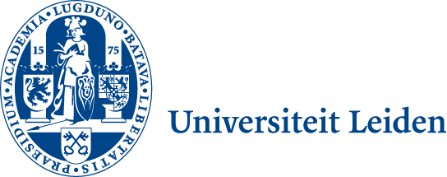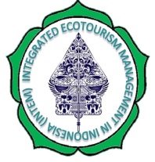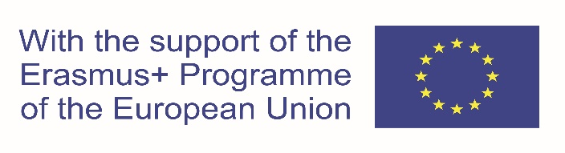

INTEGRATED ECOTOURISM MANAGEMENT IN INDONESIA (INTEM)
Project No. 599020-EPP-1-2018-1-NL International Capacity Building Higher Education-CBHE-JP
INTEM Project Coordination - Leiden Ethnosystems And Development Programme (LEAD)
Faculty of Science, Van Steenis Building, Einsteinweg 2, 2333 CC Leiden, The Netherlands
Primary Project Contact Coordinator: Prof.Dr. L. Jan Slikkerveer Email: l.j.slikkerveer@gmail.com

DETAILED DESCRIPTION OF THE PROJECT
WP 3.3
Description | Deliverable 3.3 represents the Discussion Paper on the design of the subsequent course modules, schedules, tests, and thesis work, prepared by all partners.  Media:  Paper publication and On-line publication on the INTEM Project website.
Due date | Month No. 7 in the first year of the project (approved extension to Month No. 10)
Languages | English

International Project Meeting of the EU project on INTEM in Chania, Crete (INTEM)

INTEGRATED ECOTOURISM MANAGEMENT IN INDONESIA (INTEM)
Project No. 599020-EPP-1-2018-1-NL International Capacity Building Higher Education-CBHE-JP (2018)
INTEM Project Coordination - Leiden Ethnosystems And Development Programme (LEAD),
Faculty of Science, Van Steenis Building, Einsteinweg 2, 2333 CC Leiden, The Netherlands
Primary Project Contact Coordinator: Prof.Dr. L. Jan Slikkerveer Email: l.j.slikkerveer@gmail.com

WP 3.2 Discussion Paper on the design of the subsequent course modules, schedules, tests and thesis work prepared by all partners - Prof.Dr. L.J. Slikkerveer
…………………………………………………………………………………………………………………………………………………………..
Date: 28.9.2019-7.10.2019
Due Date: Month No. 10 in the first year of the INTEM project (extension of 3 months approved)
Place: Chania, Greece
Discussants: Participants /Project staff of partner institutions (LU, ASTEK, MAICH, UNPAD, UPI, TST, MTF)
Moderator: Prof.Dr. L.J. Slikkerveer, Primary Project Contact (PCoCo)
………………………………………………………………………………………………………………………………………………………………………

During the preparation time for the discussion paper of WP 3.3, the structure of the discussion has followed a circular flowchart of a continuing sequence of steps in order to provide a guide for the discussion of the components of the design of the course modules, as indicated below:
Discussion Paper WP 3.3
Circular flowchart of a continuing sequence of steps in order to provide a guide for the discussion of the components of the design of the INTEM course modules (WP 3.3).

Introduction
The discussion among the INTEM project partners in WP 3.3 embarks on the input of their knowledge and experience in general ecotourism management, while they are focussing on the design of the course modules with the objective to develop an adequate body of knowledge of innovative modules which are elaborating on a new integrated approach of ethno-, eco-, cultural- and community-based tourism management.
In addition, a combination is sought with advanced ICT and digital communication tools in order to provide a synthesising education programme capable to deliver skilled cadres of such expert ecotourism managers with a view to contribute to solving the increasingly complicated management problems in the tourism sector in Indonesia in a sustainable way.
The modules of the proposed new Master Course are discussed within the time framework of the 12-months’ academic calendar as part of the educational system of the 3 target HEI’s in Indonesia (UNPAD, UPI & TST). The structure of the modules of the new Master Course links up with WP 3.3 on the Design of the Course Contents.

As previously been agreed upon during the group discussions of the preparatory phase of the INTEM project, the actual discussion of this WP of the relevant issues of the design of the modules of the course is centred around the following 4 main subjects:

1. Course modules (step 1)
2. Schedules (step 2)
3. Tests (step 3)
4. Conclusion of the discussion (Step 6)

Guiding Powerpoints (cf. Annex: Document 3.3.1)

1. Course modules (step 1)
The supporting modules of the contents are distributed over the agreed 3 core themes (‘streams’) as indicated below, and encompass the following 8 modules, of which the contents are further discussed in detail by the participants.

Stream 1: Integrated Ecotourism

- Teaching module 1 (Integrated ecotourism management & hospitality management)
- Teaching module 4 (Industrial regulations & service providers)

Stream 2: Community-based management

- Teaching module 2 (Tourism planning and development)
- Teaching module 5 (Tourism policy & tourism impact assessment)

Stream 3: Sustainable tourism development

- Teaching module 3 (Ecotourism, sustainability and sustainability indicators)
- Teaching module 6 (Tourism marketing, market research,& strategy formulation

Combination of Stream 1, 2 & 3
- Teaching module 7 (Fieldwork/vocational training) .This module provides the practical training environment in the tourism sector. Embarking on the key training and learning strategy of problem-based learning in a practical setting of the tourism sector, the selection of a specific destination as a case study will provide students with knowledge in the fields of applied tourism development and destination management and will render them familiar with exploration and application of theoretical perspectives in a ecotourism setting.

- Teaching module 8 (Supervision of the thesis). This module provides the vital elements for teaching students to plan and outline of a good thesis and break down the components to complete a systematic framework for building a thesis on the basis of the theory and supporting literature review, the collected fieldwork data set and the Interpretation of Findings, leading up to the final conclusion. Special attention will be paid to linguistic and editing issues.

2. Schedules (step 2)
As indicated above, each of the schedules of the 8 modules will cover 3 months and will be distributed along the 3 core ‘streams’ of the course, amounting to the 4 trimesters of the entire period of time of the calendar of the course, encompassing 4 x 3 months = 12 months.

3. Tests (step 3)
The discussion indicates that the participants regard it important that regular tests of the progress of the students will be evaluated and monitored through the organization of regular examinations at the conclusion of each of the 8 modules. The feed-back of these examinations will be provided and monitored by the evaluation protocols for teachers and students, as elaborated in WP 6.1 Quality Plan: Presentation of Teachers Evaluation Protocol.

4. Conclusion of the discussion (Step 4)
The conclusion of the discussion will review the final structure of the Master Course on the basis of the results to be expected from the students in their tests, examinations and final thesis through the sequence of the teaching and training phases of the Master Course, which covers the 12-months’ period of time.

The innovative aspects of this design include the integrated approach of the dynamics of a ‘top-down’ versus a ‘bottom-up’ approach towards a synthesis of local and global systems of knowledge and practice, which are focused on the realization of sustainable ecotourism management.
Moreover, the project partners discuss the development of adequate innovative programmes in which a new integrated approach of ethno-, eco-, cultural- and community-based tourism management, combined with advanced ICT and digital communication tools in order to provide a synthesising education programme capable to deliver skilled cadres of such expert ecotourism managers to contribute to solving the increasingly complicated management problems in the tourism sector in a sustainable way.

As mentioned above, the organisation and set-up of the structure of the contents and modules of the new Master Course is reported in Deliverable 3.5 on the Report of the final programme of the innovative curriculum on integrated ecotourism management, prepared by all partners.

Annex: Doc. 3.3.1 Guiding Powerpoints for the Discussion of the Course Modules

