INTEGRATED ECOTOURISM MANAGEMENT IN INDONESIA (INTEM)
Project No. 599020-EPP-1-2018-1-NL International Capacity Building Higher Education-CBHE-JP
INTEM Project Coordination - Leiden Ethnosystems And Development Programme (LEAD)
Faculty of Science, Van Steenis Building, Einsteinweg 2, 2333 CC Leiden, The Netherlands
Primary Project Contact Coordinator: Prof.Dr. L. Jan Slikkerveer Email: l.j.slikkerveer@gmail.com

DETAILED DESCRIPTION OF THE PROJECT
WP 6.1
Description | Deliverable 6.1 represents the presentation of the Teachers Evaluation Protocol.  Media:  Paper publication and on-line publication on the INTEM Project website
Due date | Month 24
Languages

International Project Meeting of the EU project on INTEM in Chania, Crete (INTEM)

INTEGRATED ECOTOURISM MANAGEMENT IN INDONESIA (INTEM)

INTEM PROJECT
ON THE DEVELOPMENT OF THE MSC PROGRAMME ON
INTEGRATED ECOTOURISM MANAGEMENT IN INDONESIA

QUALITY PLAN
PRESENTATION OF THE
TEACHERS EVALUATION PROTOCOL
WP6.1 OF YEAR I

2019

Introduction

During the Joint INTEM Meeting in Chania from 28.9.2022-7.10.2022, the participants discussed the design and preparation of the Teachers Evaluation Protocol which will be implemented at the end of teaching and training activities by the teachers/trainers of the Tutor Training Programme (Year II) and the Master Course Programme (Year III).

The design of the teachers/trainers evaluation protocol of the INTEM Master Course is based on the determination of the objectives of the Course. These objectives are established as the INTEM Project Goals as stated in the description of the INTEM Project Proposal.

The INTEM Project Proposal states the following four-phased goals of the INTEM Master Course Programme:

- Establishing and strengthening the Netherlands-Indonesian-Greek institutional partnership network in ecotourism management and development, including the design of a quality control and monitoring system of the project throughout its life cycle, and the set-up of a new project website for information and communication;

- Developing a new, interdisciplinary curriculum on Integrated Ecotourism Management (INTEM);

- Teaching and certifying university staff and professors in advanced knowledge and skills of the contents of the new master course, and in innovative teaching methods and techniques for effective transfer of expert knowledge and skills to future students;

3. Implementing, evaluating and disseminating the new MSc Course into the Indonesian system of higher education for future human resources development in the inclusive ecotourism sector in Indonesia.

In WP6, the INTEM Project Team has developed a new curriculum on INTEM consisting of 8 course modules to be lectured by the certified teachers/trainers to the students.

During phase III the contents of the six student modules and the additional seventh training module will be transferred to the tutors through lectures, assignments and examinations ending up in certification of the tutors as future teachers of the six student modules.

The completed Teachers Evaluation Protocol (INTEM) provides appropriate reporting, analysis and documentation of the Teachers Evaluation and Assessment results for reflection, feed-back and follow-up of the activities of the subsequent work packages, scheduled at the benchmarks to take place at the end of the above-mentioned Tutor Training Programme (Year II) and the Master Course Programme (Year III).
During the preparation time of the Teachers Evaluation Protocol of WP 6.1, its completion has followed the appropriate protocol for the advanced evaluation of the teaching-learning process implemented in the European Space for higher education (ESHE), represented in the diagram below.
The advantage of this new approach is that it not only evaluates the effects of the evaluation itself beyond external assessment, but also introduces a new model for interactive assessment of the teaching-learning process, embarks on a new conceptualization of the more dynamic, interactive teaching-learning process from both the teacher’s and the students’ point of view.

The approaches are summarized in the graphic representation of the DEDEPRO Model, an acronym which represents the different phases of the teaching-learning process: DESIGN - DEVELOPMENT - PRODUCT
(cf. De la Fuente 2000; De la Fuente & colls. 2003; De la Fuente & Justicia 2007; De la Fuente & Martínez 2004).

In the current digital age, the situation of higher education in the educational system both in programme countries as well as in partner countries shows a need to improve teaching and learning processes. On the basis of a ‘common ground approach’.

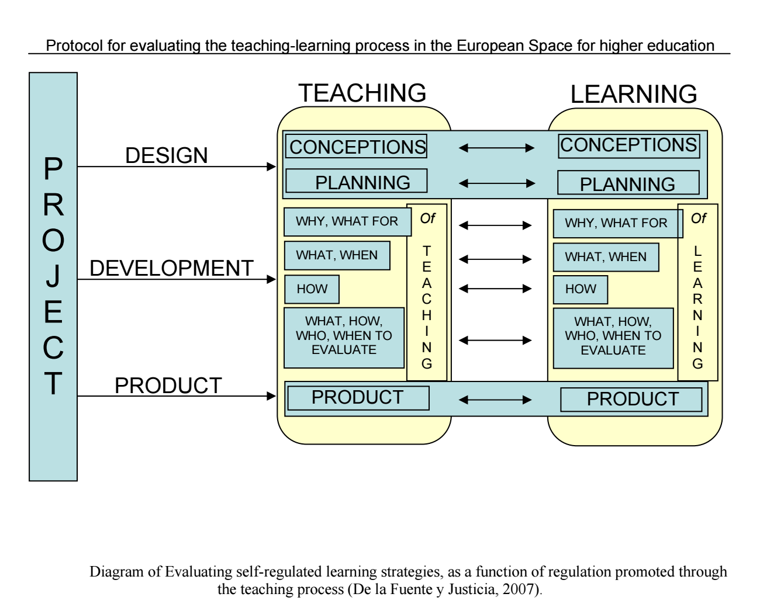
The group discussions of the preparatory phase of the INTEM project are based on the following 3 main interacting phases in the teaching-learning process, leading up to the completion of the protocol of the teachers evaluation (end product):

- DESIGN
- DEVELOPMENT
- PRODUCT

1. DESIGN
The design of the teaching-learning process is based on an interactive approach, that is, from the teacher’s and students’ point of view. It is meant to prevent the teacher’s failure to make important informational elements explicit at different points in the teaching-learning process.

2. DEVELOPMENT
Similarly, the development of the of the teaching-learning process is based on an interactive approach, that is, from the teacher’s and students’ point of view. It is meant process is based on an interactive approach, that is, from the teacher’s and students’ point of view.

4. PRODUCT
The end product of the of the teaching-learning process is based on an interactive approach, that is, from the teacher’s and students’ point of view. It is meant to embark on a process, i.e. the Teacher’s Evaluation Protocol (INTEM) is based on the quantity and quality of performance and competencies regarding the acquisition of the themes, subjects and topics, etc. provided and acquired through the teaching-learning process.
The result is an indirect instrument to measure the degree of how well the design and development of the teaching-learning process are implemented throughout the Master Course.
5. CONCLUSION: Teacher’s Evaluation Protocol (INTEM)
The Teacher’s Evaluation Protocol is developed for the teachers/trainers for the assessment of the modules of the course, and are built up on the following 5 components:
1. General data to identify the teaching process
The general data will be collected in order to identify the teaching process

2. Protocol for evaluating the process of preparing the Subject Teaching Guides
This part of the protocol is designed with a view to enable teachers/trainers to implement formative self-assessment through Subject Teaching Guides.

3. Protocol for evaluating characteristics of the Subject Teaching Guides
This part of the protocol is designed to encourage the competency in teaching, reflection and improvement This protocol is designed with a view to enable teachers/trainers to implement formative self-assessment through Subject Teaching Guides.

4. Protocol for evaluating development of the Teaching-Learning Process
This part of the protocol is designed to collect information on how well the students have acquired and developed their own knowledge of the contents of the modules
5. Protocol for evaluating the end-product: Performance, Competency Acquisition and Satisfaction
This part of the protocol is designed on the basis of the experience to collect information on 3 aspects of the teaching process, i.e. a) teachers satisfaction with the teaching process.; b) teachers satisfaction with the learning process., and c) students satisfaction with the teaching process.

The elaborated end product in terms of the evaluation forms includes the following:

A TAECHERS/TRAINERS

B STUDENTS

TEACHERS EVALUATION PROTOCOL (INTEM) (cf. De la Fuente Arias 2007)

A TEACHERS/TRAINERS

- GENERAL DATA TO IDENTIFY THE TEACHING PROCESS (INTEM)
  - NTEM COURSE / MODULE DATA
1.1.0. NAME OF INSTITUTION:
1.2.0. NAME OF COURSE / MODULE:
1.2.1. CODE:
1.3.0. REQUIRED?
1.3.1. FOR WHAT DEGREE PROGRAM(S)?
1.4.0. ECTS Credits:
1.4.1. ECTS Theory Credits:
1.4.2. ECTS Practical Credits:
1.5.0. USE OF VIRTUAL RESOURCES
1.5.1. ENTIRELY ONLINE
1.5.2. WEBCT SUPPORT:
1.5.3.WEBSITE:
1.6.0. PROCESS UNDER ASSESSMENT:
1.6.1. THEORY:
1.6.2. PRACTICAL:
1.6.3. BOTH:
- TEACHERS DATA
2.2.0. DEPARTMENT:
2.3.0. AREA OF KNOWLEDGE:
2.4.0. AGE: 2.5.1. FEMALE: 2.5.2. MALE:
2.6.0. YEARS OF TEACHING EXPERIENCE:
2.7.0. YEARS OF TEACHING EXPERIENCE WITH THIS COURSE / MODULE:
3. CLASS MEMBERS DATA
3.3.0. NUMBER OF STUDENTS ENROLLED
3.3.1. ATTENDANCE OF THEORY CLASSES
3.3.2. ATTENDANCE OF PRACTICAL CLASSES
3.3.3. ATTENDANCE OF FIELDWORK/ VOCATIONAL TRAINING

4. TEACHER/TRAINER EVALUATION (http://programevaluation.org/downloads.htm)
4.1 | 4.1.Detailed Level | Aggregate Level
4.1.1 | Makes good use of examples and illustrations to help his explanations | The learning and teaching methods encouraged participation
 | Stresses important points.
 | Shows enthusiasm.
 | Shows that he enjoys teaching.
 | Presents ideas in an interesting way.
4.1.6 | Enhances student interest by giving them opportunities to participate actively in the learning.
4.1.7 | Uses humour effectively to maintain  student interest.
4.1.8 | Gives clear explanations. | I understood the lectures
4.1.9 | Presents material at, or near, the correct level for me.
Makes it clear how each topic fits into the
subject as a whole.
Meaningfully relates material to other
Fields of study and to practical experiences.
4.1.12 | - Presents challenging thought provoking  - ideas which stimulate students to think  - for themselves.
4.1.13 | - Explains difficult concepts clearly and under-  - standably. | Ideas and concepts were presented clearly
4.1.14 | - Interprets abstract ideas and theories  - clearly
4.1.15 | Uses several concrete examples to illustrate each new concept.
4.1.16 | Appears to have a thorough knowledge of the subject.
4.1.17 | Seems knowledgeable in many ways.
4.1.18 | Is always punctual for classes.
4.1.19 | Has motivated me to do my best work.
4.1.20 | Found ways to help me answer my own  questions.

5. FEEDBACK
5.1 Detailed Level Teacher/Trainer |  | Aggregate Level
5.1.1 | Informs us of our progress. | Ideas and concepts were presented clearly
5.1.2 | Encourages and praises good work.
5.1.3 | Suggests ways we can improve.
5.1.4 | Uses well designed self assessment  questions which help me monitor my own progress.

6. ORGANISATION
6.1 Detailed Level  The teacher/tutor showes evidence of good organisation by: |  | Aggregate Level
6.1.1 | Having everything going to schedule. | The course is well organized
6.1.2 | Closely following the introductory outline
6.1.3 | Explaining the objectives for each week clearly.
6.1.4 | Making clear the weekly work requirements and assessment requirements.
6.1.5 | Effectively coordinating the various parts of the course (reading, tutorials, lectures etc.).
6.1.6 | Writing examinations and assign-ments which reflected and assessed important aspects of the subject matter
6.1.7 | Returning assignments promptly.
6.1.8 | Scheduling assignments with sufficient frequency to provide adequate feedback on our progress.
6.1.9 | Closely relating subject objectives with the material taught

7. DIFFICULTY
7.1 Detailed Level  The teacher/trainer: |  | Aggregate Level
7.1.1 | Has chosen an appropriate amount of required work.
7.1.2 | Has chosen a reasonable amount of material to be covered
7.1.3 | Sets high standards for students.
7.1.4 | Makes the subject sufficiently difficult to be stimulating.
7.1.5 | Wrote examination questions which were unreasonably detailed
7.1.6 | Has chosen a reasonable amount of material to be covered.
7.1.7 | Wrote examination questions which stressed unnecessary memorization

8 PERSONAL CONTACT

8.1 Detailed Level  The teacher/trainer through personal contact |  | Aggregate Level
8.1.1 | Wrote examination questions which stressed unnecessary memorization | Was responsive to student needs and problems
8.1.2 | Is tolerant of other points of view.
8.1.3 | Does a good job of answering questions
8.1.4 | Is friendly.
8.1.5 | Is flexible.
8.1.6 | Treats students with respect.
8.1.7 | Encourages constructive criticism.
8.1.8 | Is willing to meet and help students privately.
8.1.9 | Gives individual attention to students needing such
8.1.10 | Allows students to volunteer their own opinions.
8.1.11 | Allows and promotes class discussion
8.1.12 | Allows students to disagree and ask questions
8.1.13 | Praises students for good ideas or useful contributions.
8.1.15 | Shows a good sense of humour.
8.1.16 | Acts as a member of the group rather than an autocratic leader.
8.1.17 | Creates a relaxed, non-threatening atmosphere.

THE ASSESSMENT PROCEDURES

9 THE WRITTEN ASSIGNMENTS

9.1 Detailed Level |  | Aggregate Level
9.1.1 | Seemed carefully chosen.
9.1.2 | Were interesting and stimulating.
9.1.3 | Made students think
9.1.4 | Had clear and specific instructions.
9.1.5 | Required a reasonable amount of time and effort.
9.1.6 | Were relevant to and integrated with what is presented in the unit.
9.1.7 | Were assessed fairly and reasonably.
9.1.8 | Were returned promptly.
9.1.9 | Were a valuable part of the course.
9.1.10 | Were assessed in a way which reflected prior statements made about assessment of assignments.
9.1.11 | Had realistic deadlines.
9.1.12 | Were enjoyable to do.
9.1.13 | Required too much reading beyond the lecture notes, reader and texts.

10 THE EXAMINATIONS

10.1 Detailed Level |  | Aggregate Level
10.1.1 | Concentrated on the most important points and topics in the lectures/ tutorials, readings and texts etc. | The method of assessment were reasonable
10.1.2 | Seemed to have been carefully and conscientiously prepared
10.1.3 | Was the right length.
10.1.4 | Was clearly worded.
1O.1.5 | Seemed to be a good measure of student knowledge and under-standing.
10.1.6 | Was creative and required original thought.
10.1.7 | Was assessed very carefully and fairly

11 GRADES AND RESULTS

11.1 Detailed Level |  | Aggregate Level
11.1.1 | Was assessed very carefully and fairly
11.1.2 | Grades were assigned fairly and impartially.
11.1.3 | The grading system was clearly explained.
11.1.4 | The teacher/tutor has a realistic idea of good performance
11.1.5 | My result reflected my ability in the subject.

THE LEARNING MATERIAL - INSTRUCTIONAL FEATURES
12. Generally

12.1 Detailed Level  The learning materials provided by the teacher/trainer: |  | Aggregate Level
12.1.1 | My result reflected my ability in the subject. | Learning materials were relevant and useful
12.1.2 | Made a valuable contribution to my learning.
12.1.3 | Were easy to read and understand.
12.1.4 | Were well integrated with the text, readings etc.
12.1.5 | Aroused and maintained my interest.
12.1.6 | Covered all the necessary content.
12/1.7 | Were well integrated with assign-ments.
12.1.8 | Were structured to help my learning
12.1.9 | Were too long, with too much reading.
12.1.10 | Were too theoretical.
12.1.11 | Were excellent overall.
12.1.12 | Were well presented and produced
- SUGGESTIONS / PROPOSALS FOR HELPING TO IMPROVE MY OWN LEARNING PROCESS (INTEM)

B STUDENTS

1. STUDENTS’ ASESSMENT FROM THE TEACHING-LEARNING PROCESS I(NTEM)
SCALE FOR ASSESSING THE TEACHING-LEARNING PROCESS OVER AN EXTENDED PERIOD
Please circle the option which best reflects your idea about the teaching-learning process for this
course or module, on a scale where 1= strongly disagree and 5= strongly agree.
THE TEACHING PROCESS: AGREEMENT SCALE
Strongly Disagree | 1
Agree | 2
Unsure | 3
Agree | 4
Strongly Agree | 5
4.1. The general approach is useful in my educational development. |  | 1 | 2 | 3 | 4 | 5
4.2. The teacher explained the rationale for what we were learning. |  | 1 | 2 | 3 | 4 | 5
4.3. Teaching objectives were clear. |  | 1 | 2 | 3 | 4 | 5
4.4. The teaching objectives helped me in building my own knowledge. |  | 1 | 2 | 3 | 4 | 5
4.5. The teaching content was appropriate. |  | 1 | 2 | 3 | 4 | 5
4.6. Course content which addressed facts and concepts seemed appropriate to me. |  | 1 | 2 | 3 | 4 | 5
4.7. Course content which taught procedures seemed appropriate to me. |  | 1 | 2 | 3 | 4 | 5
4.8. Course content which addressed attitudes, values and rules seemed appropriate to me. |  | 1 | 2 | 3 | 4 | 5
4.9. The teacher encouraged my involvement in the learning process. |  | 1 | 2 | 3 | 4 | 5
4.10. The teaching approach encouraged relevant, useful learning. |  | 1 | 2 | 3 | 4 | 5
4.11. Materials used in the course / module were appropriate |  | 1 | 2 | 3 | 4 | 5
4.12. The time dedicated to each topic was appropriate. |  | 1 | 2 | 3 | 4 | 5
4.13. The teacher’s behavior (interaction, attitude, etc.) was appropriate. |  | 1 | 2 | 3 | 4 | 5
4.14. I think the assessment strategies used were appropriate. |  | 1 | 2 | 3 | 4 | 5
4.15. In general, the teaching process was appropriate. |  | 1 | 2 | 3 | 4 | 5
4.16. I understood the general structure of the course / module. |  | 1 | 2 | 3 | 4 | 5
4.17. The importance of what we were learning was clear to me. |  | 1 | 2 | 3 | 4 | 5
4.18. I had clear learning objectives. |  | 1 | 2 | 3 | 4 | 5
14.9. My learning objectives helped me build my own knowledge. |  | 1 | 2 | 3 | 4 | 5
4.20. I was able to sort out the content to be learned. |  | 1 | 2 | 3 | 4 | 5
4.21. I have adequately worked through the facts and concepts to be learned in this course / modul |  | 1 | 2 | 3 | 4 | 5
4.22. I have put into practice the procedures to be learned in this course / module. |  | 1 | 2 | 3 | 4 | 5
4.23. I have acquired the attitudes, values and rules to be learned in this course / module. |  | 1 | 2 | 3 | 4 | 5
4.24. I was actively involved in the learning process. |  | 1 | 2 | 3 | 4 | 5
4.25. I adequately planned and regulated my own learning. |  | 1 | 2 | 3 | 4 | 5
4.26 The resource materials I used (reference books, etc.) were sufficient. |  | 1 | 2 | 3 | 4 | 5
4.27. The time I dedicated to learning each topic was adequate. |  | 1 | 2 | 3 | 4 | 5
4.28. I had regular attendance, that is, I attended most classes.
4.29. I used appropriate self-evaluation strategies during the learning process
4.30. In general, my learning process was appropriate.
- SUGGESTIONS / PROPOSALS FOR HELPING TO IMPROVE MY OWN LEARNING PROCESS (INTEM)

