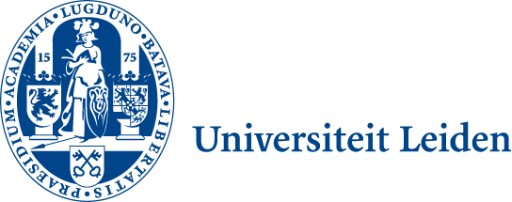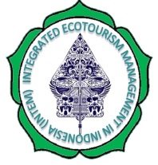

INTEGRATED ECOTOURISM MANAGEMENT IN INDONESIA (INTEM)
Project No. 599020-EPP-1-2018-1-NL International Capacity Building Higher Education-CBHE-JP
INTEM Project Coordination - Leiden Ethnosystems And Development Programme (LEAD)
Faculty of Science, Van Steenis Building, Einsteinweg 2, 2333 CC Leiden, The Netherlands
Primary Project Contact Coordinator: Prof.Dr. L. Jan Slikkerveer Email: l.j.slikkerveer@gmail.com

Deliverable No. 2.2 represents the Report on the results of the Case Studies of the Educational and Societal Need Assessment, based on the execution of the case studies in Indonesia and jointly formulated by the partners P1, P4, P5 and P6.

Annex: 2.2.1

INTEGRATED ECOTOURISM MANAGEMENT IN INDONESIA (INTEM)
INTEM
REPORT ESNA STUDY
ON THE ESNA SURVEY FOR THE EDUCATIONAL AND SOCIETAL ASSESSMENT
(ESNA) ON THE DEVELOPING A MSC PROGRAMME ON THE INTEGRATED ECOTOURISM MANAGEMENT IN INDONESIA (INTEM)

2019
__________________________________________

RESPONDENTS
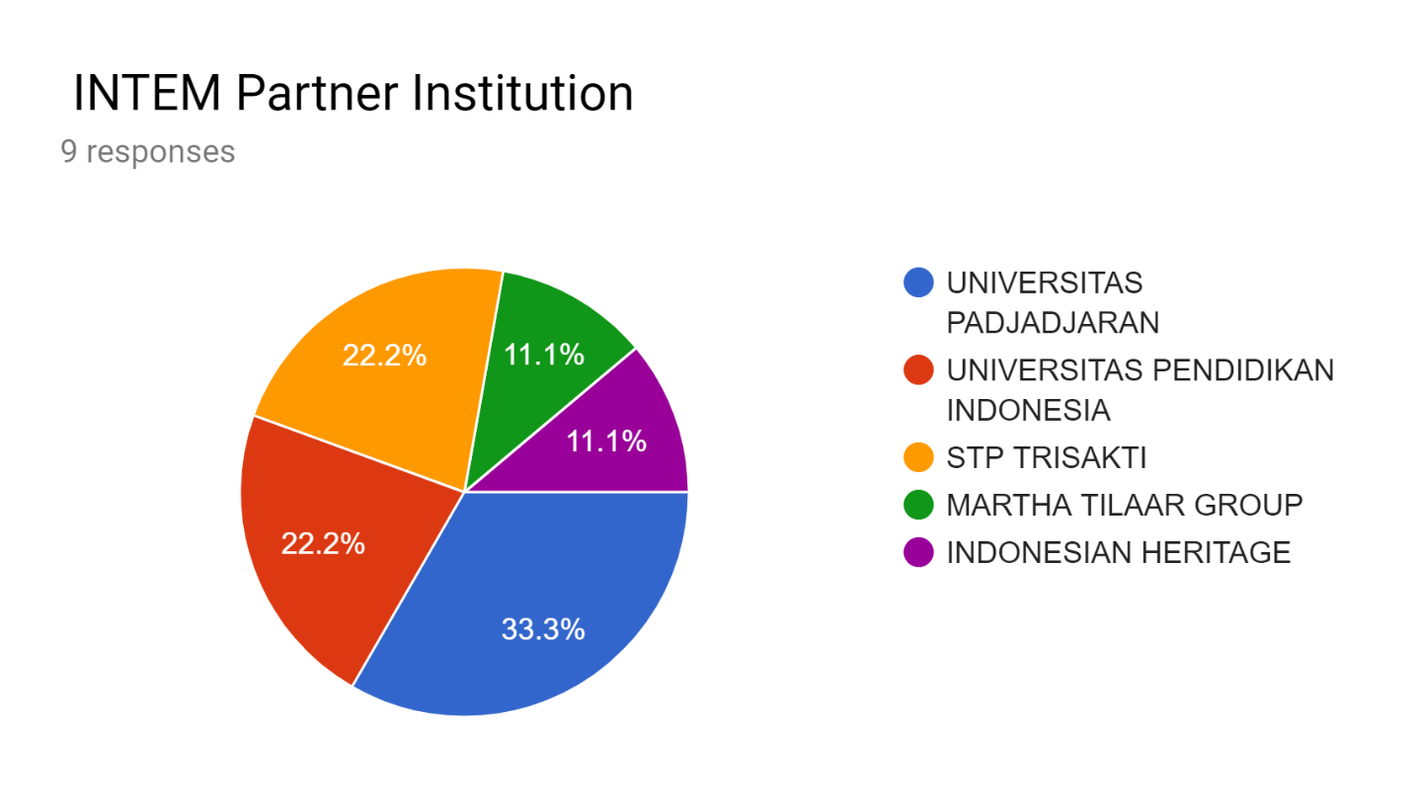

Date of completion of the Questionnaire
9 responses

2
9
2
10
3
12
2

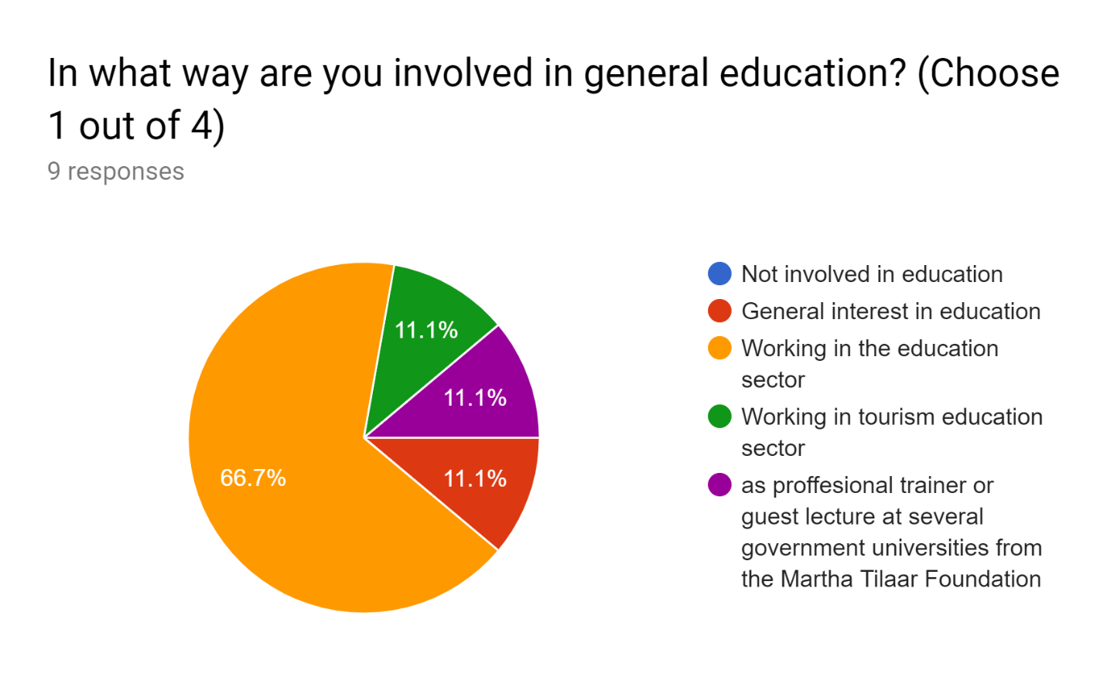

Can you provide some more information about your choice?
9 responses
A Lecturer at the Department of Mathematics to teach about Statistics especially in Stochastic Processes, Time Series Analysis, Spatial and Spatio Temporal Modeling and as a Head of Science and Technology Studies Center FMIPA Unpad.
I teach tourism sociology on bachelor level. I also work closely with several tourism lecturers and researchers for the last 10 years
That is my profession
tourism education sector prepare skill (knowledge and attitude for manpower in tourism planning, hospitality industry and destination
Teaching, Researcher and Community Services through my Institutions.
Lecturer
Conduct teaching, research and community service in the tourism education sector
I am working in the Martha Tilaar Foundation, non profit education institution in Indonesia, who providing several facilitation programs for SMEs in cosmetics and tradisional medicines field, community development, women empowerment program around Indonesia archipelago. I am also guest lecture in the Pharmacy School of Institute Technology Bandung and in the Medical Faculty of Indonesia University (Jakarta), as well conducted facilitation program for SMEs, as ASEAN expert in Good Manufacturing Practices in Cosmetics and Traditional Medicines field.
I am now retired but my career spanned 35 years in international higher education, including a few years lecturing in Indonesian language and literature at university in Australia

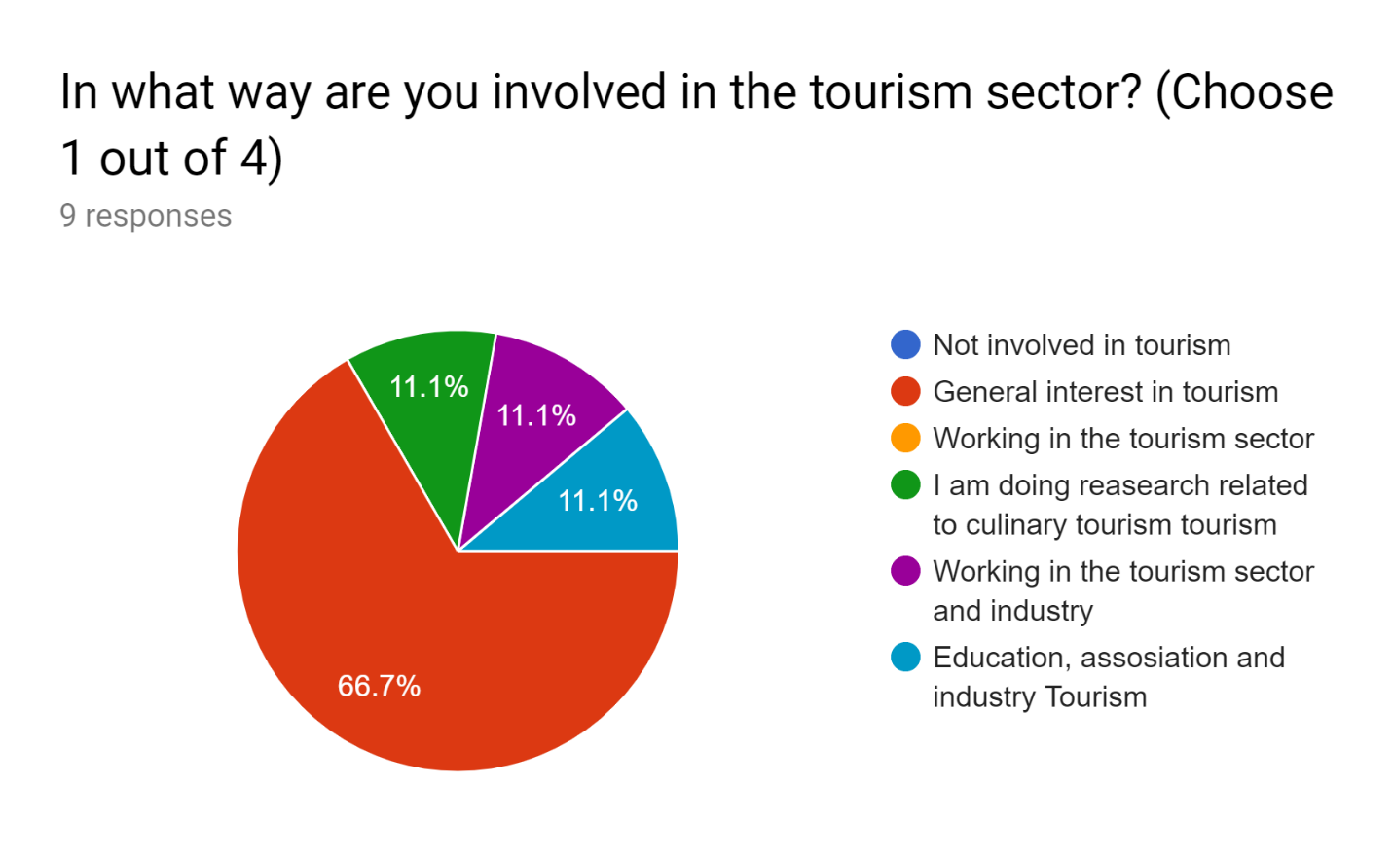

Can you provide some more information about your choice?9 responses
In our studies center, especially in Ethnoscience Division we study and do the research of Ethno-mathematics and Ethno-informatics for cultural preservation and supporting Indonesian tourism based on indigenous knowledge of each location.
I have been working with Ministry of Research and Higher Education for the last 3 years to develop programs to enhance research skills of Indonesian tourism lecturer.
Research grant from ministry of education
Firstly, education sector conducted research on community and industry. The result of the research project will be delivered for community development and industry. All feedback from the community transformed into lesson plan in lecturing on tourism education sector.
My concern is to study on how community could be involved in the tourism decision and participated in the tourism development.
Interest in traveling and tourism
• As a speaker in the Education and Industry Tourism sector • As an assessor of the national accreditation association for higher education • As Administration of the Association of Indonesian Tourism Higher Education Institutions (HILDIKTIPARI).
Can you provide some more information about your choice? 1. Lead by the Martha Tilaar Foundation dan PT. Martina Berto Tbk., since 1998 we have set-up the Kampoeng Djamoe Organik in Cikarang, West Java, as eco education center in the field of MAC (Medicinal, Aromatic, and Cosmetic) plants organic cultivation program, the usage of MAC plants for health and beauty treatment, as well for combat global warming. 2. As a form of our commitment to environmental preservation and relating to the "CEO Water Mandate", Martha Tilaar Foundation team successfully lead and held a program to clean water and provide healthy water supply in Gajah Wong river, at Depok District - Sleman, Yogyakarta from 201 - 2015. This Grebek Air Gajahwong UN Water Mandate Program in Yogyakarta, was the collaboration program, where with the partnership of Martha Tilaar Forundation, the Indonesia Global Compact Network, the local community and local government of Sleman, we have restored and cleaned Gajahwong water resources, set up community sanitation program, create simple MAC plants home gardens, and household waste bank program for the community who live along the Gajahwong river. Through this partnership program, this Gajahwong program got the MDG award in June 2013 from the Indonesia government . 3. With the collaboration with the NTFP-EP Indonesia, we have conducted integrated workshop in Palu (Central Sulawesi), as well with the Burung Indonesia, similar workshop in Marisa (Gorontalo – North Sulawesi). The goals of these two workshops mainly for the empowerment community development program, by set up the community integrated business plan and eco-tourism program based on their local biodiversity resources that available in their villages.
At no point in my career have I been involved in tourism. However, as I live and travel across Indonesia, I have become quite interested in how areas are being developed for tourism, and have personally observed both the positive and negative factors
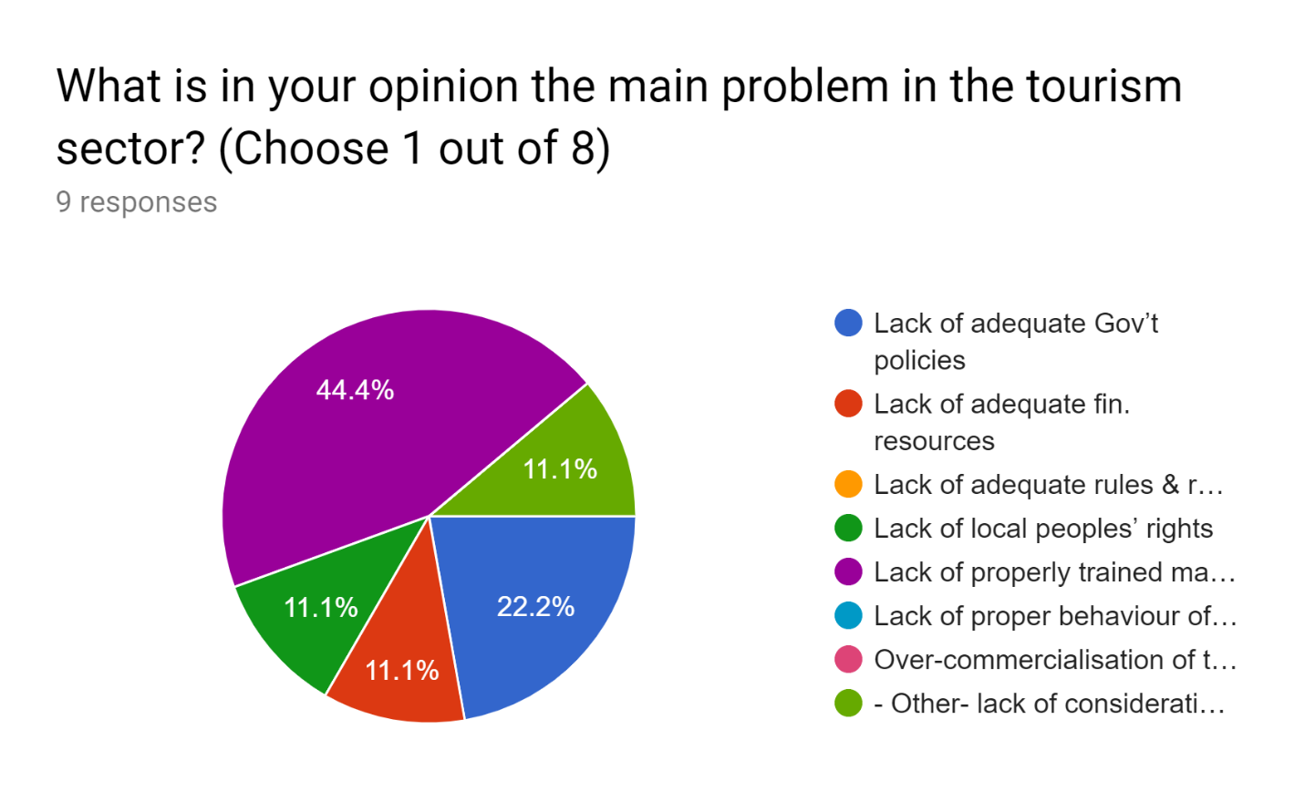

Can you provide some more information about your choice?8 responses
In my opinion, the tourism sector needs to be supported by a trained workforce, both in theory and practice. Currently, tourism education is quite a lot in Indonesia, but it still needs to be improved in the study of indigenous knowledge understanding of Indonesian culture in particular and other cultures in the world to be applied in daily life. In addition, it needs to be supported with adequate facilities and infrastructure in developing human resources in the field of tourism.
All points are actually the main problem of tourism sector in Indonesia. However, I believe the lack of adequate Government policies is the main source of problem in Indonesia tourism sector, as most of tourism policies are more politically correct and only good in concept, but facing difficulty in implementation.
We need some more grant from ministry of research and education
Indonesia tourism sector has variety of natural and cultural resources. But there is a gap between potential tourism sector resources to properly trained manpower. This should be overcome through formal and informal tourism education where link and match program should be implemented.
No regulation from the government
Tourism needs more properly formal and informal trained manpower
As a rich land and maritime bio-diversity resources, as well as the largest archipelagic country in the world, Indonesia has potency to develop natural eco-tourism programs, since we have abundant beautiful panorama with MAC plants resources, both at land and maritime diversity areas. Unfortunately, we lack of good human resources who can lead the development at the local village(s), as well the potency of community development program to create better welfare for local community, and foreign exchange for Indonesia government. In developing integrated land and maritime tourism, we should consider to preserve our land and marine ecosystems so that environmental sustainability can be achieved and managed by credible well-trained human resources. By providing good education program in integrated eco-tourism management, we hope can get several leaders who can identify the potential for: • good prospects of ecotourism located in Indonesia; • analyse the internal and external environment land and marine ecotourism; • development of sustainable land and marine ecotourism program in Indonesia, through empowering local communities and preserve the local wisdom knowledge; • development of land and marine tourism industry networks; • set up infrastructure development with local and central government institutions; • set up marketing ecotourism program and products; • improve land and maritime tourism security. • other.
In 2019, the government announced that it will be developing Danau Toba area. See article: https://indonesiaexpat.biz/featured/lake-toba-development-project-faces-local-opposition/ Many indigenous folk in the area are concerned at how the massive infracture development plans will impact on their daily lives, on their access to water for irrigation of their fields, as well as the impact on their traditional culture from the influx of many tourists from countries which do not necessarily understand the local culture or religious practices. See also article:
https://www.scmp.com/lifestyle/travel-leisure/article/3022863/theres-more-indonesia-bali-president-joko-widodo-plans This explains the government’s ambitious plans to develop ten areas, to transform them into areas such as “Bali”. This will further destroy many areas if the development is not carried out after much research and careful planning. In 2019, the government announced that it will be developing Danau Toba area. See article: https://indonesiaexpat.biz/featured/lake-toba-development-project-faces-local-opposition/ Many indigenous folk in the area are concerned at how the massive infracture development plans will impact on their daily lives, on their access to water for irrigation of their fields, as well as the impact on their traditional culture from the influx of many tourists from countries which do not necessarily understand the local culture or religious practices. See also article: https://www.scmp.com/lifestyle/travel-leisure/article/3022863/theres-more-indonesia-bali-president-joko-widodo-plans
This explains the government’s ambitious plans to develop ten areas, to transform them into areas such as “Bali”. This will further destroy many areas if the development is not carried out after much research and careful planning.

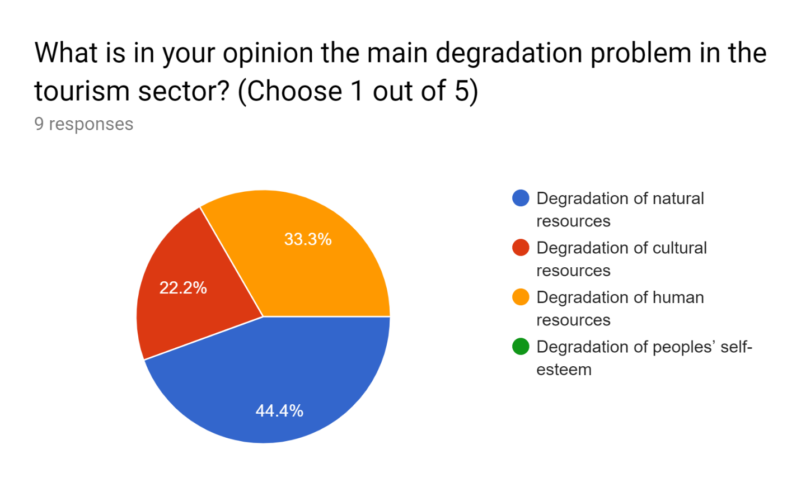

Can you provide some more information about your choice?9 responses
In my opinion, one of the main degradation problems in the tourism sector is the degradation of cultural resources. It can be influenced by globalization which supported by the development of technology information and communication in the world. Furthermore, a government, private sector, and the industry should support each other to preserve the culture based on indigenous knowledge and apply these in daily life.
Most of people who work in Tourism sector are focusing on economic impact of tourism, and tend to neglect the impact of tourism sector to natural and cultural resources
Some profesional in tourism sector dont know more about tourism
Degradation in tourism sector is started in cultural resources (characters), where the human intervention to nature exploitation. The will give feedback to human quality of life. Effects to authenticity is more consumer commodification, reduction the value of local's life.
Because of irresponsible behaviour of some tourists and lack of understanding from the local people as well as policy maker and investor, natural resources became the victim of the tourism industry
Exploitation of natural resources
human resources needs to be upgraded in terms of characters, value, ethics, as well as skill and knowledge
Negative impacts from eco-tourism occur when the level of visitor use is greater than the environment's ability to cope with this use within the acceptable limits of change.
Uncontrolled conventional tourism poses potential threats to many natural areas around the world, especially depletion of natural resources, pollution and physical impact. It can put enormous pressure on an area and lead to impacts such as soil erosion, increased pollution, discharges into the sea, natural habitat loss, increased pressure on endangered species and heightened vulnerability to forest fires. It often puts a strain on water resources, and it can force local populations to compete for the use of critical resources.
It often starts with the degradation of natural resources (over development of infrastructure) which can then, over time, lead to cultural degradation and social issues (e.g. conflict over land, business, etc)

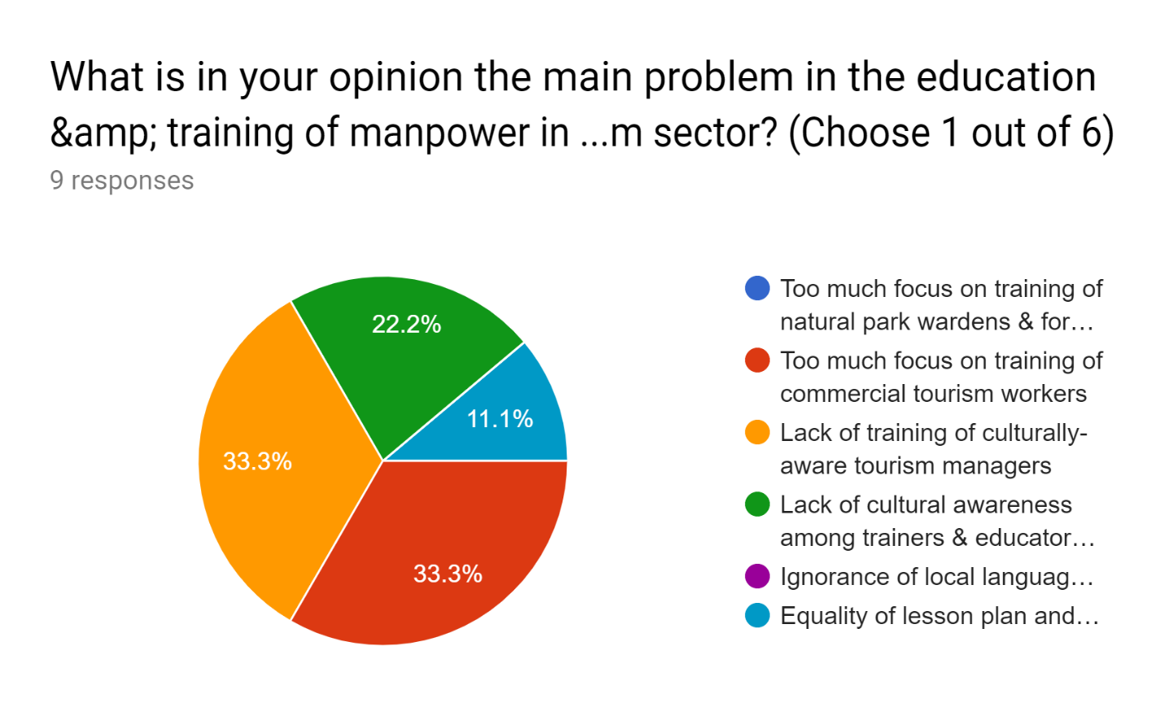

Can you provide some more information about your choice?7 responses
IIn the tourism sector, the manager of tourism should be given training more on a cultural topic based on indigenous knowledge in each location in Indonesia, not only theoretical but also in practice. For example, the manager of tourism should realization the Constitution Number 5/2017 about Cultural Advancement with notes: a. Making an integrated cultural data collection system, integrating all the main cultural data from various sources and ministries and institutions. b. Each region formulates the main ideas of regional culture, consisting of 10 objects of cultural advancement, namely oral traditions, manuscripts, customs, rites, traditional knowledge, traditional technology, art, language, folk games, and traditional sports.
In line with my previous answer, most of tourism training in Indonesia are too much focus on optimizing economic benefit from tourism sector
Its need to explore more about cultural awarness
Training of commercial tourism workers are effective in certain period of tourism development. There should be a balance between economically and commercially value to sustainability of local culture and characters. Development of tourism should understand the term of "limit to growth" in life cycle model.
Learning objectives must be clearly formulated, which includes the necessary components. Teacher competence is very important and skills for education staff deserve to be called competent
Cross-cultural training is an effective strategy in the attainment of organizational performance, targets and to provide high percent satisfaction to the tourism customers. It is recommended for the management to recognize the cultural diversity of their guests, employees, including the frontline employees, for quality service encounters with people from various cultural backgrounds that may yield better results.
One of the major problems in education, in general, in Indonesia, is the lack of well-trained teachers/educators. They are underpaid, poorly trained, and in many cases, not sufficiently aware of the problems encountered with tourism in developing nations such as Indonesia.

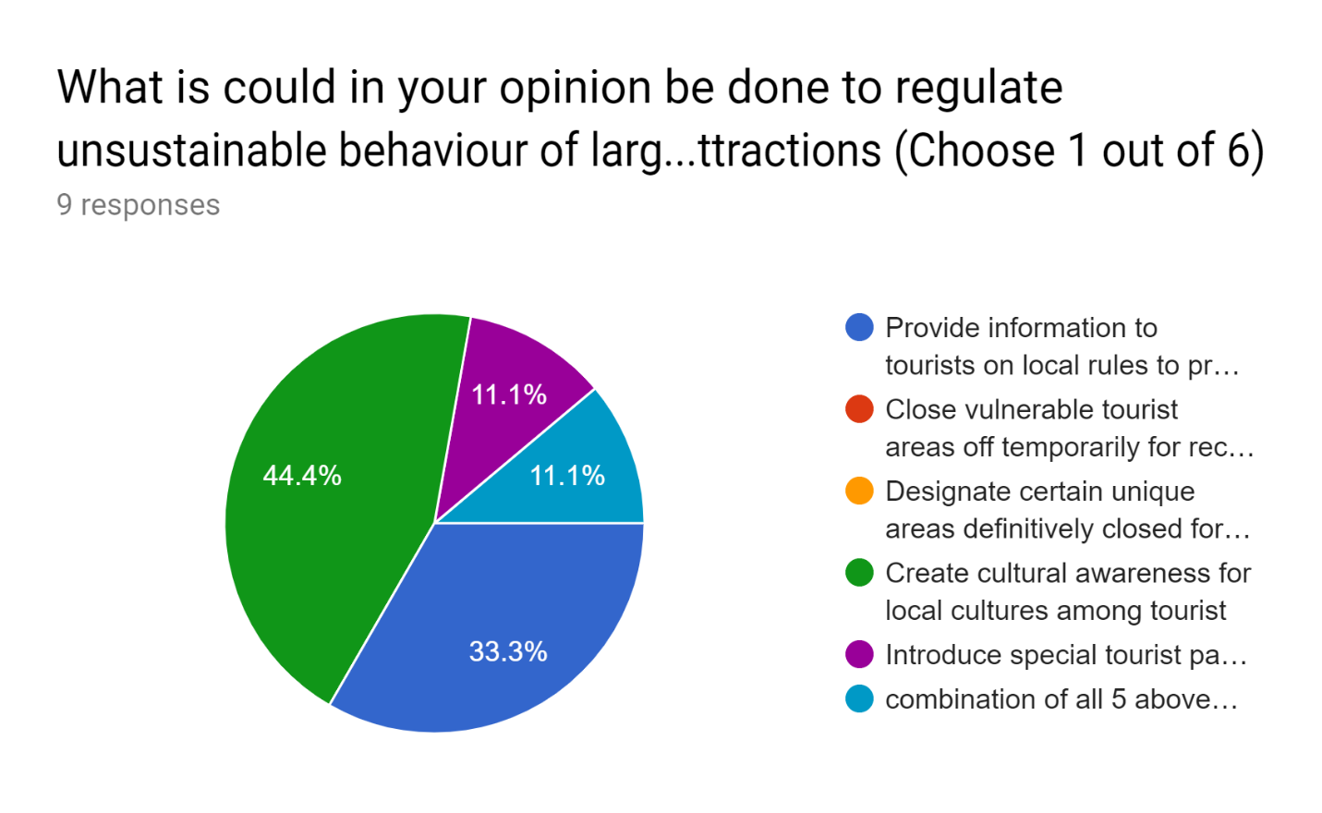

Can you provide some more information about your choice?
7 responses
The government together with the private sector in managing the tourism sector need to provide complete and correct information about a tourism location based on indigenous knowledge to tourists, both large and small. This is expected to help tourists to maintain comfort and security in a tourism place.
I believe than tourist can be well informed if the destination educate them on how to act properly in certain areas, especially protected ones. Thus, the key is to provide comprehensive information to the tourist with the right message, and through the right channel.
We have to explore local culture to attract visitors who interest on it. So we need to clasify the visitors into each segments
Tourist behavior could be constructed through awareness development. The awareness could be built into efficient media communication. The man-made media such as social media is an interesting channel for developing tourist awareness to local value. Others media, such as interpretation or signboard could be built at sacred site. Personal delivery information at the site, by local guide or tourist information center officer are still needed.
Information for tourist on local rules could be implemented by give training and delivering information through personally, website, brochures and , social media
By providing the 5 above aspects that may create threat or damage on the protected areas, we are not only ensuring the future of eco-tourism sites, but also the future of integrated eco-tourism. It’s a win-win situation for everyone involved, where the site is better protected and maintained, the tourist experiences a more pleasant visit, and the local economy is boosted as a result
In some places such as Granada, the municipality in the autonomous community of Andalusia, Spain, the local government makes tourists apply for special passes to visit the famous Al Hambra. In this way, the crowds are controlled, there is minimum destruction of the area, and the government still derives income from this tourist attraction. Currently in Indonesia, there are often hordes of tourists (e.g. to Borobudur), both local and foreign, who visit tourist attractions without much supervision from the care takers.

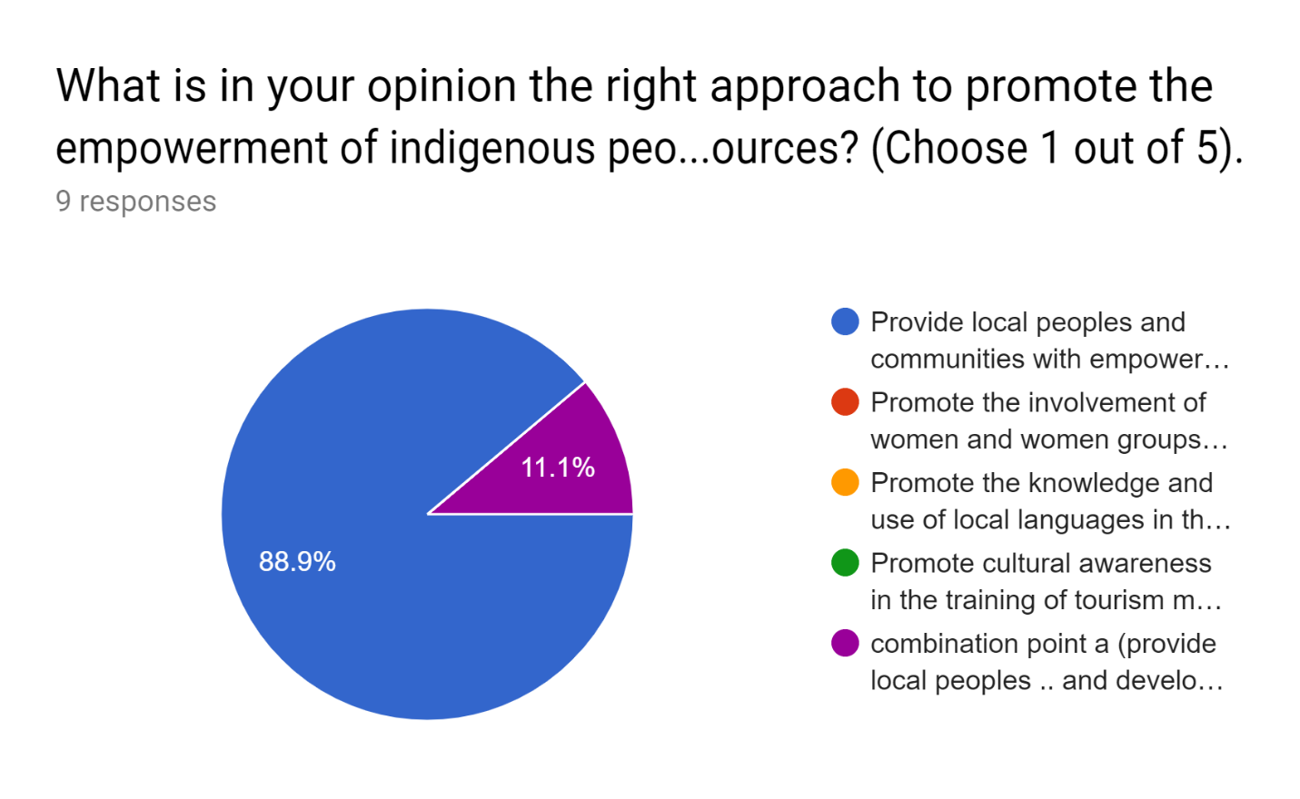

Can you provide some more information about your choice?9 responses
In the development of tourism, the involvement of the community and local communities needs to be increased and supported by structured tourism training for the community based on the indigenous knowledge of each region. Community participation is needed so that people have the opportunity to introduce their culture to tourists with the support of sufficient knowledge in the era of globalization.
We should encourage local people to decide their own future as tourism destination by giving them some basic knowledge of tourism planning, so they can create tourism sustainable programs and plans.
We have to make the planning to empower the potential indigenous people that could be interest the visitors
It is important for local people to participate in tourism planning and development. This concept is usually called as a community-based tourism. The role of tourism authority to give opportunities for locals in engagement between locals, tourism education, locals management tourism organization, skill training, marketing and built environment.
Local people should be heard of their voice regarding any decision with regards to their lands and if it is going to be utilised for tourism
Developing agreed syllabus and teaching materials
making the community as the subject of development in harmony with the concept of people centered development
Since indigenous areas have profound ethnic culture and ecological significance and sensitivity, successful integrated eco-tourism development must consider the perceptions of the indigenous community in order to build a mutual relationship grounded on respect and feasibility.

The local indigenous communities are influenced by both the positive and negative impacts of tourism. To recognize which tourism impacts are most anticipated and concerning, we should determine which and to what extent tourism impacts affect indigenous hosts’ support of alternatives for integrated eco-tourism management plans.

Local communities have the right to be consulted and involved in planning of tourist sites in their region. This will ensure that they continue to enjoy their rights as locals (e,g, land rights; religious worship rights; cultural rights etc). However, it is also important to continue to promote cultural awareness in the trg of tourism managers. The concern in Indonesia right now is that there is an influx of foreign tour guides, accompany large groups of international tourists.

These foreign guides have little knowledge or appreciation of the local culture, religions and languages. In addition, this new practice is taking away work from local tourist guides and causing friction in certain areas.

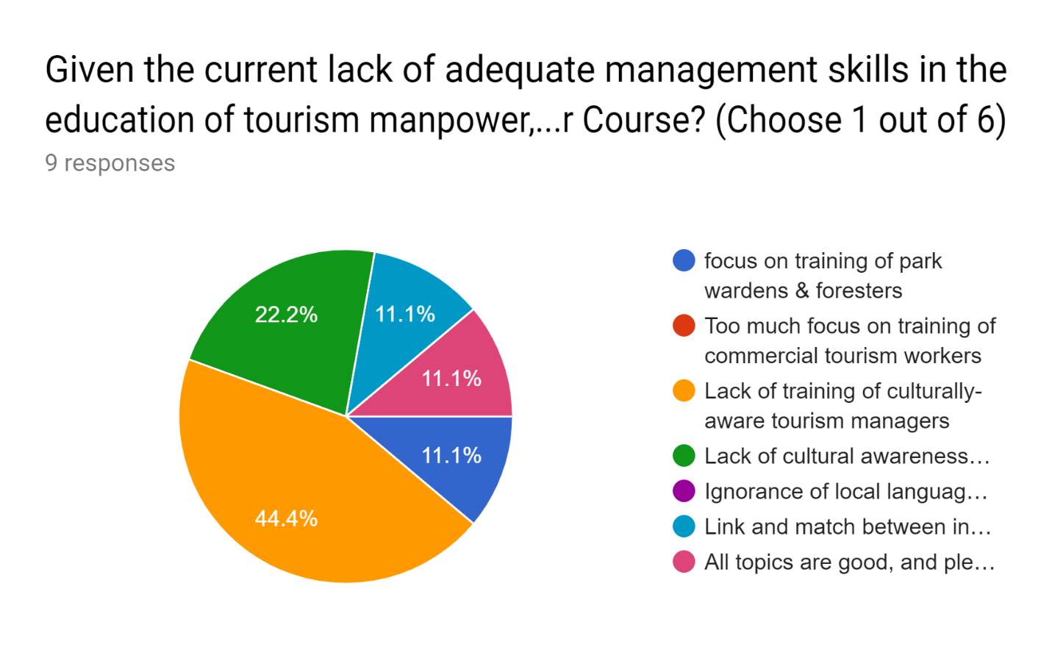

Can you provide some more information about your choice?9 responses
In the era of globalization, the field of tourism must be designed using a cultural perspective including local communities and providing more information based on local wisdom of a region.
One of the most obvious weakness in tourism education in Indonesia is the lack of research skills for both educators and managers in tourism sector. I believe strengthening this area is of important in tourism education in Indonesia
The managers have to know how to manage the cultural tourism
Lesson plan at any tourism education institution should follow the existing condition (demand of the industry). Next policy is developing curriculum that fit through consensus between stakeholder (faculty, lecturers, tourism association, and expertise). The lesson plan will cover the competencies based-skill during learning process.
Most of managers could only see from commercialized perspective
There is a need to build knowledge based on the indigenous practices
Warden of the park and foresters are in the forefront of the management of the tourist area so that increasing training capacity can support improved services and maintain tourism activities
It is high time for greater synergy between development thinking and tourism management, and there is great potential for the INTEM project to include the field of pro-poor eco-tourism issues. In tourism, there is growing recognition of the need to plan at the level of the destination. This is the ideal level at which to address the search for motors of ‘local economic development’ and for ‘anchors’ that can generate a wide range of linkages in the local economy to ensure the private sector plays its corporate role in poverty alleviation.
This requires highly practical application in eco-tourism, where the challenge for governments is how to create a set of commercial incentives that make it in the interest of tourism operators to strengthen their local linkages, while running a sophisticated commercial business
Tourism is not just about showcasing sites and offering tourists opportunities to experience food, drink and entertainment. It should be about raising an awareness of other cultures/ethnic groups. Therefore, trainers and educators must have such trg because not all Indonesians know and understand about the hundreds of ethnic groups in their own country. Nor is there always a respect for other ethnic groups and their cultures, religions and other beliefs.

What would be your advice concerning the content and subjects of the new INTEM Master Course in terms of topics and subjects? (Open-ended question)9 responses
The INTEM program is equivalent to a master's program which can be focused on integration studies in Management, Economics and Tourism supported by Econometrics Modeling supported by cultural studies based on local wisdom of each region in Indonesia supplemented by gender studies in various activities. For example, if it is carried out in Unpad, local culture in the form of Sundanese culture can be chosen which can be introduced through various Ethnoscience studies including Ethno-economics, Ethno-communication, Ethno-botany, Ethnomatematics, Ethno-informatics, and other topics.
Tourism and Ecology; Art, Culturd and Culture; Ethno-Tourism; Edutourism; Big Data, Information System and Technology; Destination Management; Sustainability in Tourism Sector/ Industry; Community based Tourism;
That could be put the tourism focus on ecotourism
Sustainable link and match education
Cultural-based Tourism
Local knowledge
• Indigenous Ecotourism • ICT in Ecotourism • Code of Ethics in Ecotourism
The new INTEM Master Course program consist of 2 parts, the General Aspects and the Special Aspects that describes below.project, that may consist of: • Introduction to ecotourism and sustainable tourism; • Ecotourism definitions, markets and environments; • Environmental, experiential, economic and socio-cultural aspects of ecotourism; and • Ecotourism planning and management • Hospitality tourism management • Consumer Behaviour and Destination Management • Transport in Travel & Tourism • Managerial Communication Skill Development • Tourism entrepreneurship • Managing tour package manageement • Resort planning and development • Research methodologi in integrated eco-tourism management • Community partnetship • International tourism management Special aspects of INTEM project • Cultural and local wisdom aspects, including the impacts of tourism development in rural indigenous destionations • Pro-poor eco-tourism management • Advanture tourism and business management that focuses on the operational and risk elements of running a successful and safe activity. • Development and conservation of natural local resources strategy
- An appreciation of tourism from the point of view of importance of natural resources; cultural heritage; land rights - What are the true values of tourism, apart from the monetary aspects - The role women can play in tourism development and planning - How to instil an awareness of the environment in young Indonesians, throughout their education

Can you provide some more information about your advice?9 responses
The INTEM program was developed to follow the needs of the Indonesian people for managers who master specialized fields that integrate management, ecotourism supported by cultural studies based on local wisdom in each region in Indonesia. This program is intended to provide educational services equivalent to a master's program at level 8 in educational qualifications in Indonesia, so graduates of this program are expected to have the ability to analyze problems in the field of management and ecotourism in an integrated manner supported by an understanding of Indonesian culture. In accordance with the criteria of master education at Padjadjaran University, the educational services in the INTEM program are used learning methods in the form of teaching modules supplemented by practical field work guidance or special skills training within a specific time duration and is equipped with workshops, formal presentations, discussion groups, and several field trip. The topic of teaching materials in general can be classified in the study of Management, Tourism Management, Development of Culture-based Econometrics Models to support the field of Tourism, Study of Gender in Tourism, Improvement of Foreign language skills (English, Mandarin, etc.) compiled in educational activities for 3-4 semesters. All educational activities can be provided by academics from various universities as well as tourism practitioners involved in the INTEM international consortium.
All aforementioned subjects are of important in today’s era. Particularly because of the lack of concern on those subjects in tourism master program in Indonesia
That need to strengthen the ecotourism
INTEM Master Course should understand the link and match concept in the region. Ecotourism is an systemic innovation to protect the environment and locals quality of life (both economy and culture) in the third country. INTEM then, should make a strategic mapping of Indonesia typical tourism product and destination.
The decision of Tourism in a specific area should be based on local people's decision and acknowledgement to their cultural considerations
Indigenous knowledge
• Because Indonesia has many ethnic group with local wisdom and local culture, where the indigenous must be the subject not merely an object • Because the changing times and changes in demographic structure and technological advances require an integrated form of tourism • Because tourism requires ethics in planning, implementing and managing.
General aspects of INTEM project, that may consist of: • Introduction to ecotourism and sustainable tourism; • Ecotourism definitions, markets and environments; • Environmental, experiential, economic and socio-cultural aspects of ecotourism; and • Ecotourism planning and management • Hospitality tourism management • Consumer Behaviour and Destination Management • Transport in Travel & Tourism • Managerial Communication Skill Development • Tourism entrepreneurship • Managing tour package manageement • Resort planning and development • Research methodologi in integrated eco-tourism management • Community partnetship • International tourism management Special aspects of INTEM project • Cultural and local wisdom aspects, including the impacts of tourism development in rural indigenous destionations • Pro-poor eco-tourism management • Advanture tourism and business management that focuses on the operational and risk elements of running a successful and safe activity. • Development and conservation of natural local resources strategy.

- An appreciation of tourism from the point of view of importance of natural resources; cultural heritage; land rights - What are the true values of tourism, apart from the monetary aspects - The role women can play in tourism development and planning - How to instil an awareness of the environment in young Indonesians, throughout their education

What would be your advice concerning the set-up and structure of the new INTEM Master Course in terms of duration in weeks cq. months? (Open-ended question)9 responses
The INTEM Program can be proposed to be a concentration of the IMM Program as an International Masters Program at Padjadjaran University, so that the curriculum structure can refer to the IMML program. month, and 3 months for guidance of writing the Master Thesis, enriched with a number of workshops, formal presentations, discussion groups, and some field trips.
- Multi discipline Program; - Promote mobility students; - Project-Based activity; - Research-based Master Program; - Smart Class;
At unpafd it would be in concentration and consist of 9 credit. Its mean 3 subject a week
3 months
18 months including field work and thesis
There has to be agreed courses among the consortium
The Master course should provide the best expertise of all institutions involved
Duration of master course of INTEM project: a. in theory - 18 months. b. in project / research field: 6 months
Ideally, each segment must have a reasonable amount of time devoted to it so that the trainees really develop a good grasp of all aspects of tourism development, especially in a developing country.

Can you provide some more information about your advice?9 responses
The INTEM Program as a concentration of the IMM Masters Program needs to arrange curriculum to achieve the vision and mission of the study program. The curriculum in general needs to have learning outcomes that are divided into mastery of knowledge, mastery of specific skills, mastery of general skills and attitudes in accordance with level 8 of the Indonesian national qualification framework. In general, courses can be arranged based on: 1. Preparatory Subjects, 2. Basic Subjects, 3. Basic Skills Subjects, 4. Skills and Personality Development Courses. The composition of the courses is presented in the form of modules completed with workshop materials as well as field visits and thesis writing in accordance with the applicable guidelines in each of the universities where the INTEM Program will be opened.
-
3 subject focus on ecotourism
The three months duration to prepare learning process, consist of: curriculum, learning outcome, lesson plan, assessment and modules.
Following the regulation of the Indonesian Government, under the ministry of higher education, research and technology
There has to be agreed syllabus among the consortium
The course should include best practices also policy decision from developed as well as developing countries especially the participant countries
Total 4 semesters
Ideally, each segment must have a reasonable amount of time devoted to it so that the trainees really develop a good grasp of all aspects of tourism development, especially in a developing country.

